**Exp 10:**

Create a Cloning of a VM and Test it by loading the Previous Version/Cloned VM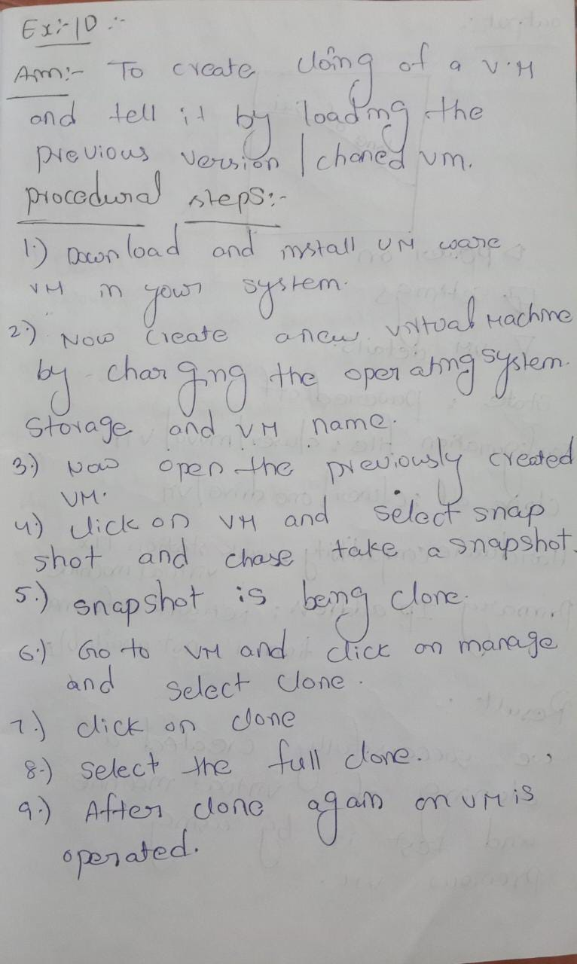

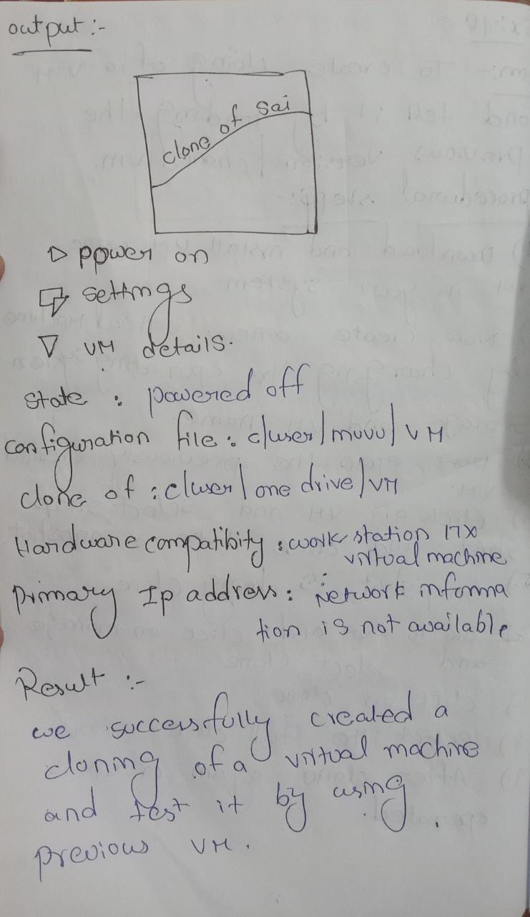

Out put:

